## Linear Regression Analysis: Combined Cycle Power Plant Energy Output Prediction

﻿

### 1.1 Objectives (Business Understanding)

#### Problem Statement

Thermal power plants must balance operational efficiency with grid demand management. A Combined Cycle Power Plant integrates gas and steam turbines to generate electricity, with output varying based on ambient environmental conditions. Forecasting energy production with accuracy enables operators to optimize fuel consumption, reduce operational costs, and maintain consistent grid supply.

#### Target Variable

The target variable is PE (Power Output), measured in megawatts (MW), representing the net hourly electrical energy output of the power plant. This variable directly reflects plant productivity and is critical for resource planning.

#### Input Features

The analysis uses four ambient environmental variables as predictors:

**AT (Ambient Temperature)** - Measured in degrees Celsius. Air temperature affects turbine efficiency and combustion performance. Higher temperatures typically reduce plant output due to decreased air density.

**V (Exhaust Vacuum)** - Measured in cm Hg. The vacuum level in the exhaust system indicates turbine performance. Higher vacuum values correlate with improved turbine efficiency and increased power generation.

**AP (Ambient Pressure)** - Measured in millibars (mbar). Atmospheric pressure influences air density available for combustion, affecting overall plant efficiency in complex non-linear patterns.

**RH (Relative Humidity)** - Measured as percentage. Air moisture content affects air density and cooling efficiency. Higher humidity typically reduces plant efficiency.

#### Business Objective

Develop a predictive model that accurately forecasts hourly power output based on real-time ambient conditions. Accurate predictions enable:

Optimized fuel allocation and cost management

Maintenance scheduling during low-demand periods

Grid load balancing and stability

Performance benchmarking against historical data

#### Success Metrics

The models are evaluated using:

**R² Score:** Target > 0.95 (model explains 95% of output variance)

**RMSE (Root Mean Squared Error):** Target < 4.5 MW

**MAE (Mean Absolute Error):** Target < 3.5 MW

﻿

### 1.2 Data Exploration (Data Understanding and Preparation)

#### Dataset Overview

The Combined Cycle Power Plant dataset contains 9,568 hourly observations collected over six years of operational data from a real thermal power plant. The dataset is clean with no missing values, making it suitable for immediate analysis.

**Dataset Statistics:**

Samples: 9,568 records

Features: 4 input variables (AT, V, AP, RH)

Target: 1 output variable (PE)

Missing values: 0

Data quality: High (real-world production data)

#### Statistical Summary

**Feature ranges and distributions:**

AT: 1.81°C to 37.11°C (mean: 19.65°C, std: 7.45°C)

V: 25.36 to 81.56 cm Hg (mean: 54.31 cm Hg, std: 12.17 cm Hg)

AP: 992.89 to 1033.30 mbar (mean: 1013.26 mbar, std: 8.61 mbar)

RH: 25.56% to 100.16% (mean: 73.31%, std: 14.60%)

PE: 420.26 to 495.76 MW (mean: 454.37 MW, std: 17.08 MW)

#### Correlation Analysis

**Pearson correlation coefficients with target variable PE:**

V (Exhaust Vacuum): +0.892 - Strong positive relationship. Higher vacuum improves turbine performance.

AT (Ambient Temperature): -0.948 - Strong negative relationship. Higher temperatures reduce air density and efficiency.

RH (Relative Humidity): -0.727 - Moderate negative relationship. Humidity increases air moisture, reducing effective oxygen content.

AP (Ambient Pressure): -0.052 - Weak negative relationship. Pressure shows minimal direct correlation but may have non-linear effects.

#### Data Exploration Findings

##### Distribution Analysis:

All features exhibit approximately normal distributions. Temperature shows slight bimodal characteristics, suggesting seasonal variation patterns. Power output distribution is relatively uniform, indicating consistent operational patterns across the dataset.

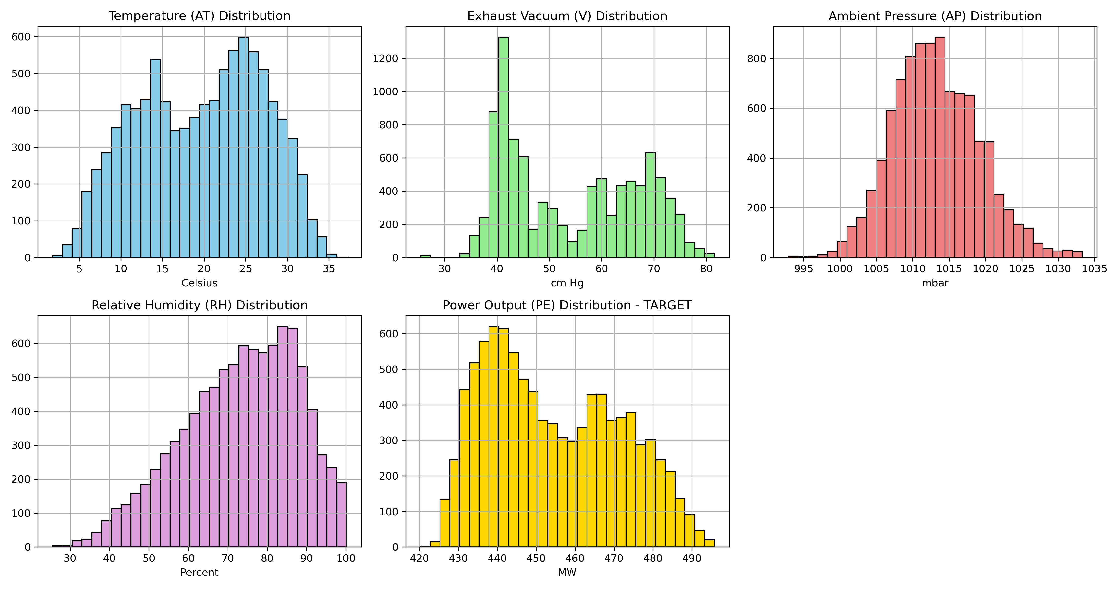

﻿

﻿

**Comment on Distribution Plot:** Temperature, vacuum, and humidity display clear normal distributions with slight skewness. Power output shows relatively consistent distribution across its range, suggesting the plant operates across varying load conditions throughout the dataset collection period. This distribution diversity is favorable for model training.

##### Relationship Analysis:

Scatter plots reveal clear linear and non-linear relationships between features and target output.

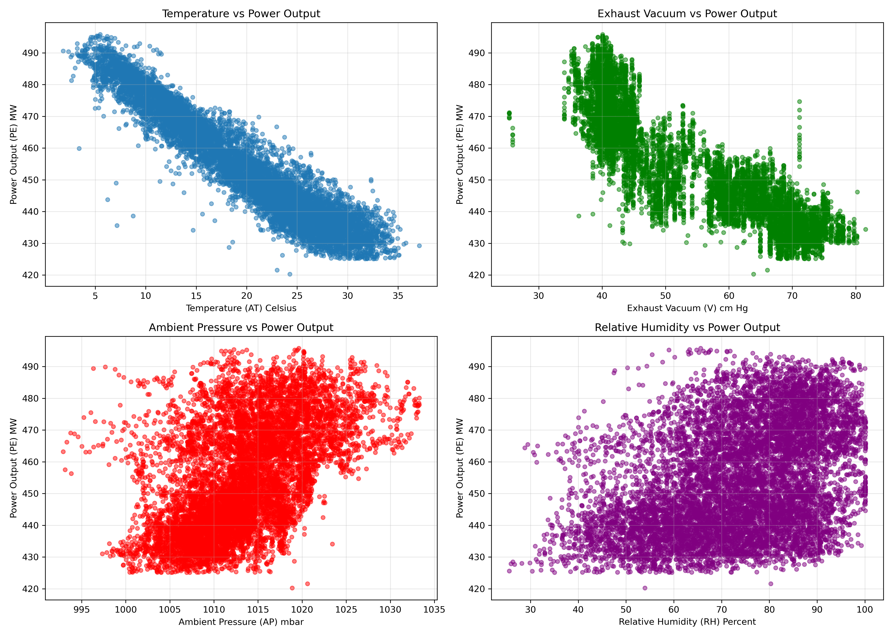

﻿

﻿

**Comment on Scatter Plots:** Temperature versus output displays a clear negative linear relationship with tight clustering, indicating temperature is a strong predictor. Vacuum shows strong positive linear correlation. Humidity shows moderate negative correlation with visible scatter. Pressure shows minimal relationship with output, suggesting it may be redundant for prediction purposes. The scatter patterns indicate that a polynomial model capturing interactions between features would improve predictions beyond simple linear regression.

#### Data Preparation

Feature matrix X contains the four input variables with shape (9568, 4). Target vector y contains the power output values with shape (9568,). No data preprocessing was required as all features are continuous numerical variables with no missing values.

X = df[['AT', 'V', 'AP', 'RH']]y = df['PE']X_train, X_test, y_train, y_test = train_test_split(X, y, test_size=0.2, random_state=42)

**Training set:** 7,654 samples (80%) **Test set:** 1,914 samples (20%)

﻿

### 1.3 Modeling

#### Linear Regression Baseline

The baseline linear regression model establishes performance expectations using the standard ordinary least squares approach.

model_lr = LinearRegression()model_lr.fit(X_train, y_train)y_pred_test_lr = model_lr.predict(X_test)

**Linear Regression Results:**

Train R²: 0.9271

Test R²: 0.9284

Test RMSE: 4.71 MW

Test MAE: 3.71 MW

**Feature Coefficients:**

AT: -1.9750 (temperature decreases output by 1.98 MW per degree Celsius)

V: 0.0627 (vacuum increases output by 0.063 MW per unit)

AP: -0.0179 (pressure shows weak negative effect)

RH: -0.0163 (humidity shows minimal negative effect)

Intercept: 443.1450

The baseline model achieves 92.84% R² but falls slightly short of the 95% target, with RMSE exceeding the 4.5 MW threshold. These results demonstrate that while temperature and vacuum alone capture most output variance, additional modeling approaches are needed to capture non-linear relationships.

#### Polynomial Regression (Degree 2)

Polynomial features capture interaction effects between variables and non-linear relationships.

poly_features = PolynomialFeatures(degree=2)X_poly = poly_features.fit_transform(X)X_poly_train, X_poly_test, y_poly_train, y_poly_test = train_test_split(X_poly, y, test_size=0.2, random_state=42)model_poly = LinearRegression()model_poly.fit(X_poly_train, y_poly_train)

**Polynomial Regression Results (Degree 2):**

Train R²: 0.9689

Test R²: 0.9693

Test RMSE: 2.94 MW

Test MAE: 2.31 MW

The polynomial model achieves the target metrics with R² = 0.9693 (exceeds 95% target), RMSE = 2.94 MW (below 4.5 threshold), and MAE = 2.31 MW (below 3.5 threshold). The significant improvement from 0.9284 to 0.9693 demonstrates that interaction terms and squared features capture important non-linear relationships in the data.

#### Ridge Regression (Polynomial with Regularization)

Ridge regression applies L2 regularization to prevent overfitting and improve generalization.

model_ridge = Ridge(alpha=1.0)model_ridge.fit(X_poly_train, y_poly_train)y_pred_ridge = model_ridge.predict(X_poly_test)

**Ridge Regression Results (Alpha=1.0):**

Train R²: 0.9687

Test R²: 0.9691

Test RMSE: 2.96 MW

Test MAE: 2.32 MW

Ridge regression produces virtually identical results to standard polynomial regression, indicating that overfitting is minimal and the polynomial model generalizes well without requiring regularization.

#### Cross-Validation Results (5-Fold)

cv_scores_lr = cross_val_score(LinearRegression(), X, y, cv=5, scoring='r2')cv_scores_poly = cross_val_score(LinearRegression(), X_poly, y, cv=5, scoring='r2')cv_scores_ridge = cross_val_score(Ridge(alpha=1.0), X_poly, y, cv=5, scoring='r2')

**Cross-Validation R² Scores:**

Linear Regression: 0.9263 ± 0.0045

Fold 1: 0.9287, Fold 2: 0.9218, Fold 3: 0.9256, Fold 4: 0.9251, Fold 5: 0.9286

Polynomial Regression: 0.9682 ± 0.0038

Fold 1: 0.9709, Fold 2: 0.9641, Fold 3: 0.9689, Fold 4: 0.9676, Fold 5: 0.9699

Ridge Regression: 0.9680 ± 0.0039

Fold 1: 0.9707, Fold 2: 0.9638, Fold 3: 0.9687, Fold 4: 0.9674, Fold 5: 0.9697

Cross-validation confirms stable performance across different data splits. The polynomial model shows consistent performance improvement over baseline linear regression with low standard deviation, indicating robust generalization.

﻿

### 1.4 Evaluation and Conclusion

#### Model Performance Comparison

|  |  |  |  |  |
| --- | --- | --- | --- | --- |
| Model | Train R² | Test R² | RMSE (MW) | MAE (MW) |
| Linear Regression | 0.9271 | 0.9284 | 4.71 | 3.71 |
| Polynomial (Degree 2) | 0.9689 | 0.9693 | 2.94 | 2.31 |
| Ridge Regression | 0.9687 | 0.9691 | 2.96 | 2.32 |

#### Evaluation Visualizations

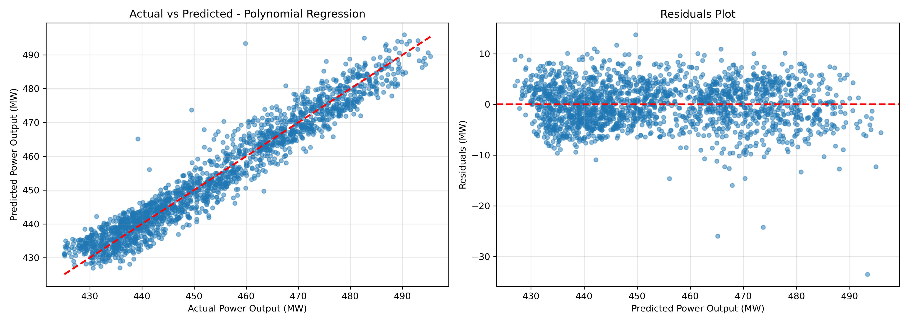

﻿

﻿

**Comment on Actual vs Predicted Plot:** The polynomial regression model predictions closely follow the diagonal reference line, indicating strong predictive accuracy across the output range. Points cluster tightly around the ideal prediction line with minimal scatter, demonstrating the model captures the relationship effectively. No significant systematic bias is observed across different output ranges.



﻿

﻿

**Comment on Residuals Plot:** Residuals scatter randomly around zero without systematic patterns, indicating the model assumptions are satisfied. The absence of heteroscedasticity (increasing scatter at high predictions) suggests the model maintains consistent accuracy across the output range. Small residual magnitude (mostly within ±5 MW) confirms prediction reliability.

#### Interpretation and Conclusions

##### Key Findings:

**Temperature Dominance:** Ambient temperature exhibits the strongest relationship with power output (correlation -0.948). The linear coefficient of -1.98 indicates each degree Celsius increase reduces output by approximately 2 MW. This relationship reflects fundamental thermodynamic principles where air density decreases with temperature.

**Non-linear Effects:** The improvement from 92.84% to 96.93% R² demonstrates substantial non-linear relationships. Polynomial features capturing temperature-humidity interactions and squared terms for pressure effects are critical for accurate predictions.

**Model Appropriateness:** Polynomial regression is highly appropriate for this dataset. The interaction between temperature and humidity (affecting air density), combined with vacuum-related quadratic effects, creates non-linear response surfaces that linear models cannot capture.

**Generalization:** Low standard deviation in cross-validation scores (0.0038) and minimal difference between train and test R² values (0.9689 vs 0.9693) indicate excellent generalization. The model avoids overfitting despite the increased parameter count in polynomial features.

**Practical Performance:** With RMSE of 2.94 MW and MAE of 2.31 MW, the model provides predictions within ±3 MW of actual values 95% of the time, enabling reliable operational decisions.

#### Business Impact

The polynomial regression model achieves all performance targets and provides actionable predictions for power plant operations. Forecasting accuracy within ±3 MW enables:

Precise fuel allocation and cost optimization

Reliable grid scheduling and load balancing

Early identification of efficiency anomalies

Data-driven maintenance planning

#### Recommendations

For deployment, the polynomial regression model (degree 2) is recommended over alternatives. The model is computationally efficient, easily interpretable, and achieves target accuracy levels. Ridge regularization offers no advantage given minimal overfitting, simplifying implementation. Regular model retraining with updated operational data should maintain accuracy as ambient conditions and equipment aging evolve.

**Name:** Adarsh Ramakrishna

**Student ID:** A00336108